Product Design
Team | 43 Sarthak Singhal, Anush Amar Mahajan, Pulkit Gera

Design Model

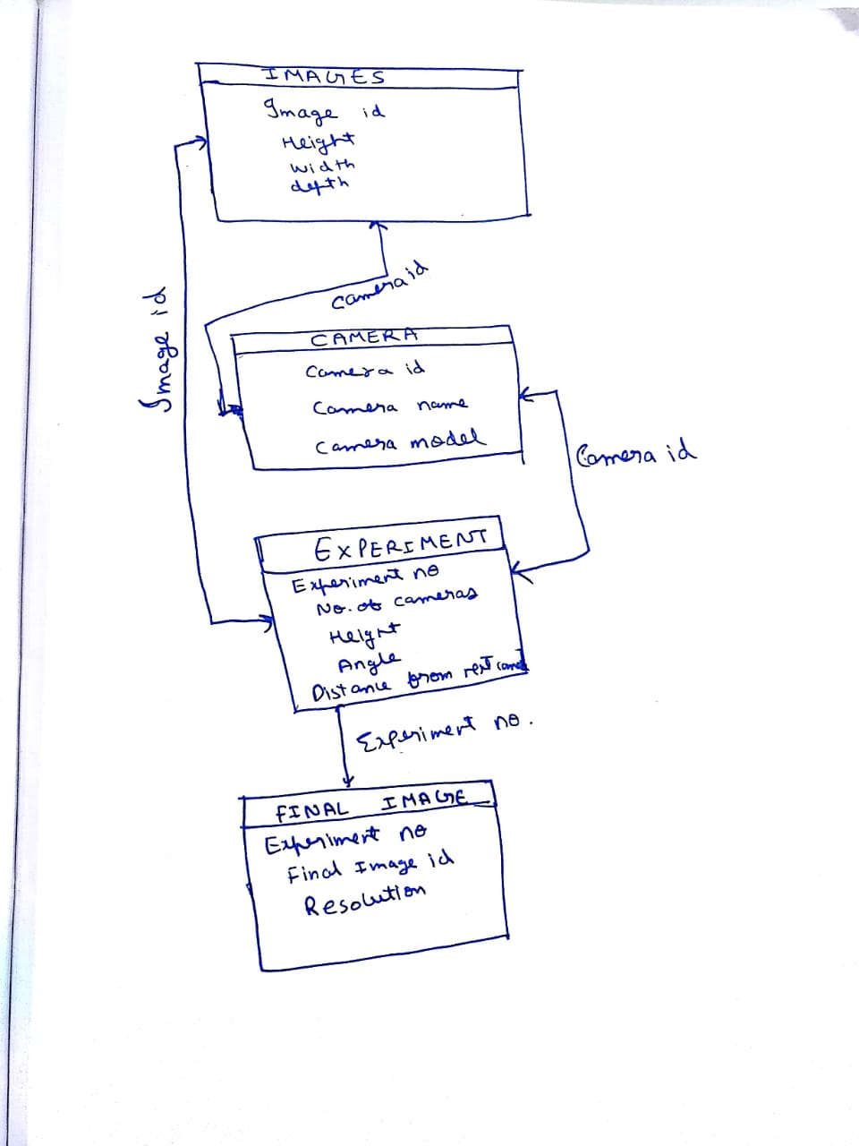

Images | Class State  - This Class stores the set of images taken from different cameras at different angles.
Cameras | Class state  Meta Data about the camera are stored. The idea is to get images which are compatible with each other during the stitching algorithm.
Experiment | Class state  - In this we basically store the image created after each iteration and store the different metrics like height and depth. This is useful as we can use it to get the perfect metrics for the homography  Class behavior  - Etc.
.

Sequence Diagram(s)

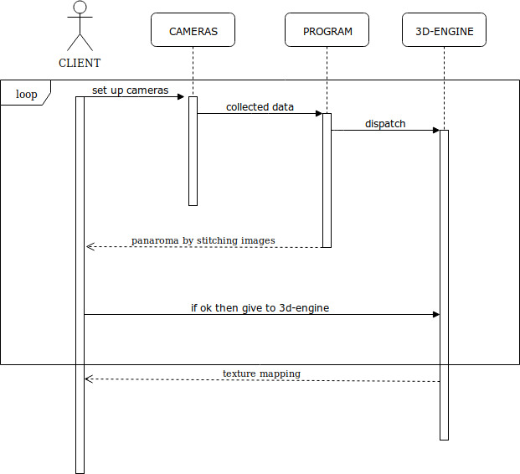

Design Rationale
This is a running list of issues that arise as your design process proceeds. This is an important section of the design document as it captures the thought process of the product's designers. It includes why or why not (rejected solutions) a design decision was made and supports future changes to the product. It should be updated whenever a design change occurs.

It is RARELY the case that the first design you consider is the best one that you can come up with that meets the requirements and that can be implemented, tested, and delivered on schedule. Your instructor will be looking for signs that you considered at least a few approaches, and that you had a coherent rationale for preferring the design your team eventually adopts.
This is the place to record such thoughts – what alternatives did you consider? What are the strengths (and deficiencies) of the final design compared to the other alternatives considered? Why did you select the approach you finally chose? This last question should be answered with an eye to the tradeoffs inevitably involved in creating an appropriate design.

